**Set-of-Creative-minimalism-retro framed art**

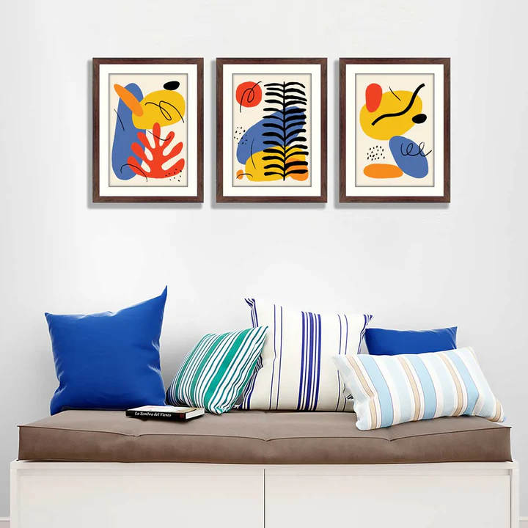This set of creative minimalism retro-framed art brings an elegant blend of simplicity and nostalgia to any space. The trio of abstract landscape designs, featuring flowing patterns in warm earthy tones and serene cool shades, is enriched by the graceful presence of crane birds in flight. Framed in sleek black borders, the artwork complements a variety of decor styles. Paired with a cozy seating area adorned with striped and solid cushions in complementary colors, this arrangement creates a visually balanced and inviting ambiance, ideal for adding character to modern or retro-inspired interiors.